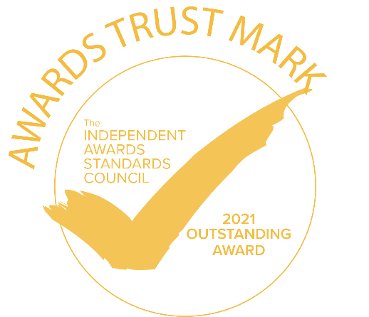
The Independent Awards Standards Council Trust Mark - Application Form
The Awards Trust Mark scheme is a not-for-profit accreditation programme run by The Independent Awards Standards Council with the goal of, as the name suggests, enhancing trust between those entering awards schemes, and the organisations running them.

It is based around a voluntary code of conduct that awards organisers commit to. All levels of the Trust Mark require a director to sign up to this code of conduct. The highest levels (Advanced and Outstanding) not only have the most extensive list of elements within the code of conduct, but are also validated* by calling a randomly selected awards judge and awards entrant.

The scheme is not-for-profit. All individuals on the council, and organisations supporting the scheme, monitor their investments and the fees charged to award organisers are purely to cover these costs. Any surplus is reinvested back into the scheme.
The scheme is already raising standards in the industry, and we would encourage everyone entering awards to encourage the organisers to commit to the code of conduct and thus earn an Awards Trust Mark.
In order to apply for the Trust Mark please show which of the following practices you employ with a Y or a N. Please then provide a short summary to qualify how you meet the associated criteria. Also, please provide any supporting evidence referenced in your summaries in the form of a single DOC or PDF to help with the assessment process. For example, images or feedback reports, screenshots of website pages. Pasting objects into a document is acceptable.
*Please note: The validation exercise can only validate based on the most recent awards scheme, but your application is based on the elements of the code of conduct you commit to for the current/next iteration of your scheme. This possible disconnect will be factored into any validation call. Failure to implement changes that you propose will happen in future awards may result in the Trust Mark being withdrawn at a future date.

What you get for applying
Any awards scheme that earns an accreditation:
- Can use the Trust Mark logo, of the colour of accreditation that they have earned, in any marketing for a period of 12 months after accreditation has been earned. When in digital form, the logo must link to www.awardstrustmark.org website which explains what that colour accreditation means.
- Will have their awards scheme marked with a correspondingly coloured tick on the awards-list.co.uk and awards-list.com websites. These sites are the agreed locations where the accreditation level is published and can be verified. The research clearly shows that organisations choosing which awards to enter will lean towards those with Trust Marks.
- Will receive a pdf certificate for the accreditation. A posted hand-written certificate is available for £10 extra and a framed certificate is an additional £20 – to cover materials and postage.

Application form

Award name
Accreditation start date
Accreditation sought (delete accordingly)
Contact for accreditation name
Contact email address
Contact phone number

Accredited:  This level is self-certified. You tell us which criteria apply, and a director commits you to this code of conduct by signing this form. We will take your responses as factually accurate. Clearly, should it turn out that your application was not factually correct, then the accreditation will be removed.  You must meet all the criteria here.  Application fee: £95+VAT. For multiple award pricing please contact us. Please note all fees cover admin and running costs. Finances are tracked to ensure the programme is not-for-profit. | 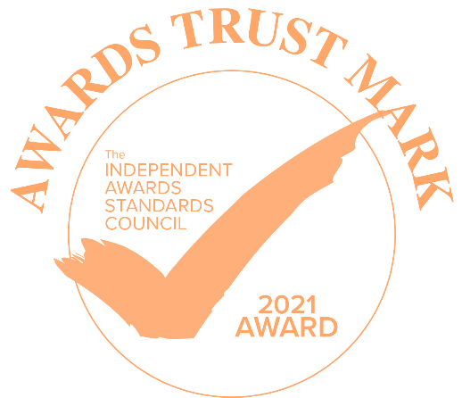

Criteria to be met. | Did this apply to the last time you ran your awards? (Y or N) | Will this apply to the next time you run your awards? (Y or N) | Please briefly explain how and to what extent you apply this process. Please provide further evidence in your supporting document where necessary.
- Awards should be open to all within the specified region and sectors stated on the website, with no unwritten filtering (e.g. it is ok to be restricted to clients or association members – but only if clearly stated. Any filtering of applicants by brand name, company size, perceived reputation etc. is not allowed).

- Judging must be strictly in accordance with the process stated on the website for both the shortlisting stage, and the final selection of a winner.

- All judges must be independent and not employed by companies that have a commercial interest in table sales, advertising etc. or a conflict of interest with the nominees. If a judge is employed by the awards organiser or sponsor then there has to be a very clear rationale for this (e.g. they are an industry expert)

- No compulsion that finalists must attend the presentation event.

- The whole programme should be well organised, with full availability of dates, rules and other important information.

- Not charging for use of logo or promotion of a win.

- Providing winners with quotes for press releases for free whenever they ask.

- Winners being publicly declared (website etc.) within 7 days of any awards event.

- Fee transparency – all fees and costs declared on the website. Including entry fee, event attendance fees, any membership fees, and optional costs like duplicate trophies (if applicable).

- Clear website in terms of dates and processes – e.g. having the deadline date clearly visible on the homepage (a date not just a countdown timer), and rules/ eligibility/ how to enter page easy to find.

- Allowing entry forms to be viewable prior to having to pay an entry fee to gain access.

- A contact email and phone number is provided on the website for those wishing to enter the awards to ask questions, with responses within 24 hours.

Advanced: “Ethical Awards Scheme Accredited”  To rate as “Advanced” you have a few extra elements to adhere to, but the main thing is that your application form will be verified.  A member of the Council will contact an applicant and a judge, chosen at random from a list of at least three (ideally five) of each, to help in the verification process.  Application fee: £300+VAT. For multiple award pricing please contact us. Please note all fees cover admin and running costs. Finances are tracked to ensure the programme is not-for-profit. | 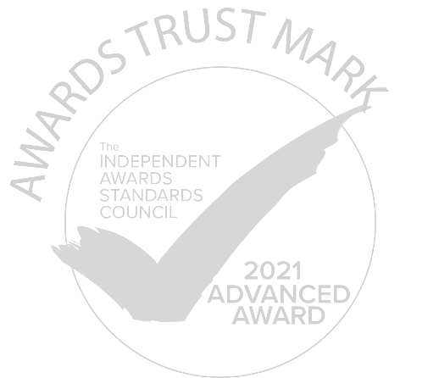

- Giving feedback to entrants on why they did not win, when asked.

- Non-disclosure agreements signed by judges (digital acceptance is acceptable if legally binding).

- Clear scoring systems used by all judges, that remove bias and inconsistency.

- All decisions on shortlisting and winning to be made by at least two independent judges.

Outstanding: “Ethical Awards Scheme Accredited”
To be rated as “Outstanding” you have a few extra elements to adhere to, and like the “Advanced” rating, your application form will be verified.
A member of the Council will contact an applicant and a judge, chosen at random from a list of at least three (ideally five) of each, to help in the verification process.

Application fee: £300+VAT. For multiple award pricing please contact us. Please note all fees cover admin and running costs. Finances are tracked to ensure the programme is not-for-profit.

- Pay to enter Awards schemes, must automatically provide feedback to all entrants.
Free to enter Awards schemes, must offer feedback to all entrants. Automatic feedback is not compulsory, unless requested by the entrant.
The Awards scheme may charge a fee for feedback only if they are free to enter.

- Some form of training given to judges. This can be a briefing pack, webinar, pre-judging briefing. But judges cannot undertake judging without some form of thorough briefing.

Verification
In order to verify Advanced and Outstanding ratings, a member of The Independent Awards Standards Council will contact a range of judges and entrants. Please provide any contact details that may help us in this process (we may also contact others based on publicly-displayed information on websites etc.)
Name | Company/Organisation | Judge/Entrant | Telephone Contact Details | Email Contact Details
 |  | Judge
 |  | Judge
 |  | Judge
 |  | Judge
 |  | Judge
 |  | Entrant
 |  | Entrant
 |  | Entrant
 |  | Entrant
 |  | Entrant

Authorisation
I confirm that the form and information is entirely accurate and I consent to a member of the Independent Awards Standards Council contacting judges/entrants for verification purposes (Advanced/Outstanding only).
I accept that, if at a later date compelling evidence comes to light that we are not acting as stated in this application form, then our processes will need to change to meet the criteria, or the Trust Mark will be withdrawn. In this circumstance, we will not be able to use the Trust Mark logos in any capacity until the concerns have been resolved.
Signature:
Name:
Job title (must be a director or equivalent):
Organisation:
Date:

Next steps:
Payment
- Costs: As listed depending on which Trust Mark you are applying for.
- How to pay: If payment is being made directly to the Independent Awards Standards Council an Invoice will be generated and sent to you. Within that invoice is a pay online now link, which will accept Visa, Mastercard and American Express and is a secure method of payment. You can either pay directly to one of the companies or individuals within the Independent Awards Standards Council listed as able to process your application.
- For any questions please call: +44(0)1273 258703

Use of the Trust Mark logo
You are welcome to use the Awards Trust Mark logo in any of your publicity. We ask that this is on the condition that the Trust Mark logo is not substantially altered in any way, and when used online links back to the Awards Trust Mark website https://awardstrustmark.org . Accreditation is for a period of one year from the date that it is awarded so use of the logo is for this period only. Continued use will require re-applying.

Changes to your awards programme.

Please inform the Awards Standards Council of any significant changes to your awards programme that mean it is substantially different from the when the application was made. Examples include (but are not limited to) changes to the judging process, rebranding, entry format requirements etc.

The Awards Standards Council reserve the right to withdraw the Trust Mark accreditation from a particular scheme if information comes to light that is contrary to the information submitted in the application, or if significant changes have occurred to the awards scheme that means it is no longer eligible.
Should your award fail to meet the standard accreditation level upon application you will not be charged.

The Independent Awards Standards Council and the Awards Trust Mark are a non-profit making exercise with the sole aim of promoting trust in the award industry as a whole for the benefit of all stakeholders. By applying for an Awards Trust Mark we hope that you will be contributing to this aim and keep within the spirit of its intentions. Please contact the Independent Awards Standards Council directly should you wish to become a member.

